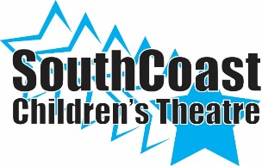
TICKET ORDER FORM

Don’t Drink the Water
General Admission: $15.00/ Adults $12.00/Children and Seniors
November 18, 2017 1:00 p.m. and 7:00 p.m.

SCCT Cast Member__________________________________

NAME | PERFORMANCE | QUANTITY | TOTAL | PAID

