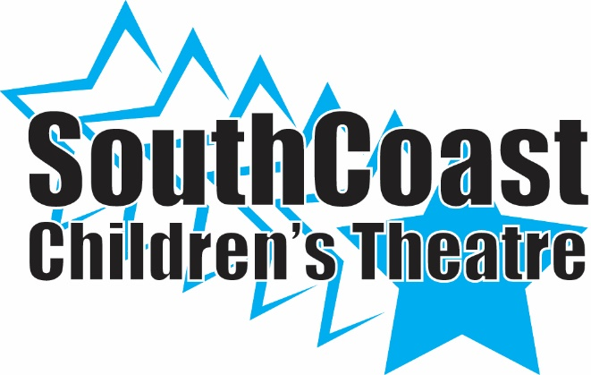
TICKET ORDER FORM

General Admission: $15.00/ Adults $12.00/Children & Seniors
May 12th at 7:00
May 113th at 1:00 & 7:00

SCCT Cast Member__________________________________

NAME | PERFORMANCE | QUANTITY | TOTAL | PAID

