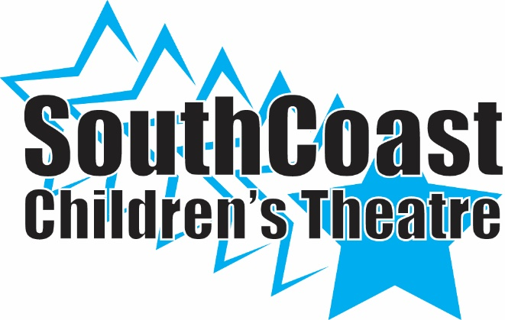
TICKET ORDER FORM

Mary Poppins
General Admission: $15.00/ Adults $12.00/Children
May 11th 7:00
May 12th 1:00 & 7:00

SCCT Cast Member__________________________________

NAME | PERFORMANCE | QUANTITY | TOTAL | PAID

