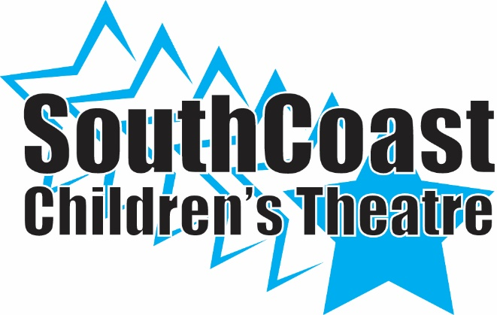
TICKET ORDER FORM

Seussical
General Admission: $15.00/ Adults $12.00/Children
May 12th 7:00
May 13th 1:00 & 7:00

SCCT Cast Member__________________________________

NAME | PERFORMANCE | QUANTITY | TOTAL | PAID

