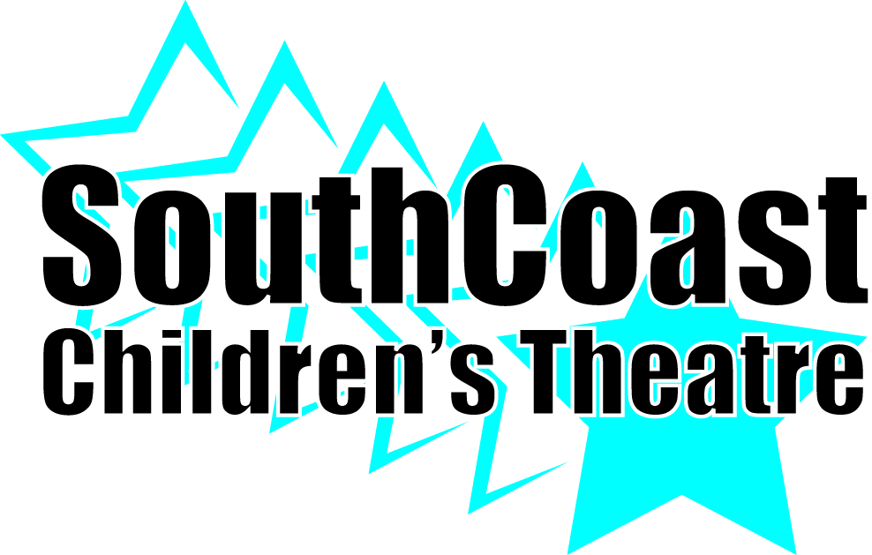
BECOMING A CORPORATE SPONSOR IS A GREAT WAY TO SUPPORT SCCT. DO YOU KNOW A COMPANY OR PERSON THAT MAY BE INTERESTED?
Corporate Sponsorship
Deadline for program ad is April 12, 2017
Premiere Corporate Sponsors: $750
Benefits include:
- Name and logo on show poster (sponsorships received by February 24, 2016)
- Name listed in the program for shows performed in the 2016 season
- Full page ad in our program for shows performed in the 2016 season
- 10 tickets to a performance of your choice
- Verbal announcement at the show
- Link on our website for one year
- Display of your logo in the lobby during a performance
Gold Corporate Sponsors: $500
Benefits include:
- Name listed in the program for shows performed in the 2016 season
- 6 tickets to a performance of your choice
- Verbal announcement at the show
- Link on our website for one year
- Display of your logo in the lobby during a performance
Silver Corporate Sponsors: $300
Benefits include:
- Name listed in the program for shows performed in the 2016 season
- 4 tickets to a performance of your choice
- Verbal announcement at the show
- Link on our website for one year
TAX FORMS AVAILABLE UPON REQUEST

